< Online Event Hall Booking Management System >

Design Document

Version 1.0



Group Id: S2002687F7
Supervisor Name: Khaqan Khawer
Revision History

Date (dd/mm/yyyy) | Version | Description | Author
15/06/2020 | 1.0 | Introduction of document  Entity Relationship Diagram  Sequence Diagram  Architecture Diagram  Class Diagram  Database Design  Interface Design  Test Cases | BC170402435

- Introduction of Design Document
- Entity Relationship Diagram (ERD)
- Sequence Diagrams
- Architecture Design Diagram
- Class Diagram
- Database Design
- Interface Design
- Test Cases
Design Document
- Introduction of Design Document
The requirement document does not specify the architectural or implementation details, but specifies information at the higher level of description. The problem statement, the customer's expectations, and the criteria for success are examples of high-level descriptions.
Sometimes, if an exact engineering detail needs to be specified, this detail will also appear in the requirement document. This is the exception and should not be the rule. These exceptions occur for many reasons including maintaining the consistency with other established systems, availability of particular options, customer's demands, and to establish, at the requirement level, a particular architecture vision.
The analysis phase defines the requirements of the system, independent of how these requirements will be accomplished. This phase defines the problem that the customer is trying to solve. The deliverable result at the end of this phase is a requirement document. Ideally, this document states in a clear and precise fashion what is to be built. This analysis represents the ``what'' phase. The requirement document tries to capture the requirements from the customer's perspective by defining goals and interactions at a level removed from the implementation details.
In the design phase, the very important decomposition of the problem leads to the development of data structures and algorithms. A functional decomposition for a distributed environment leads to a natural split of the data structures and algorithms. Examples include distributed client-server systems, where a database holds the data in a server while the algorithms manipulating the data reside on the client.

Software development process is a structure imposed on the development of the software. Similar term include software life cycle and software process. It includes many different models for such process each describes variety of task or activities that take place during the process.

The goal of logical design phase is to synchronized the knowledge of application expert and implementation expert to produce a logical model of the system which could be implemented and would work and but perhaps not optimally. This phase insure the systematic development. The process is driven by the product of the analysis phase and end in a model of software program for future development.
This Document include different diagrams like

- Entity Relationship Diagram
- Sequence Diagram
- Architecture Diagram
- Class Diagram
- Database Diagram
- Interface Diagram
- Test Cases

- Entity Relationship Diagram (ERD):
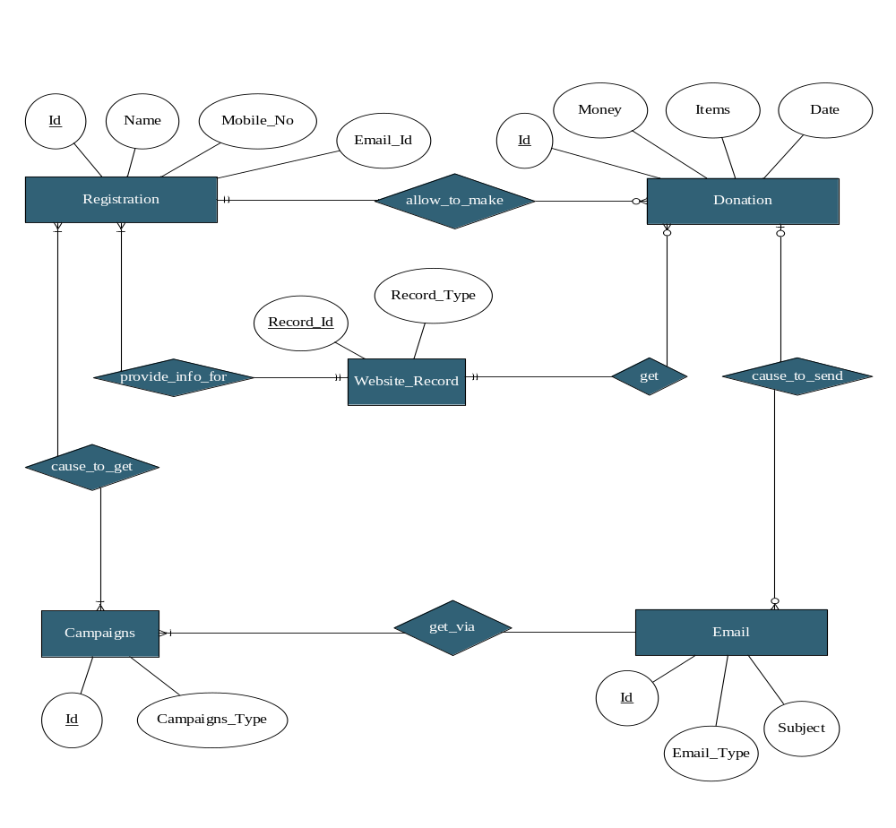

- Sequence Diagrams:
:Registartion
register()
Registered
: User

:Registartion
login (donor)
Get Login
: User

:Registartion
login (volunteer)
Get Login
: User

:Donation
;
donate()
Donated
: User

: Donation
DonateMoney()
Donated
: User

:Donation
donateTangibleItem ()
Donated
: User

: Donation
Donated
: User

donateViaPaypal ()

: Donation
Donated
: System

allowDonation(organization_Level)

:Email
getConfirmation ()
: User
Received

:Email
sendTaskReminder ()
Sent
: System

:Email
sendAppointmentReminder ()
Sent
: System

:Email
sendBatchEmail (contacts)
Sent
: System

:Campaigns
TrackFundraisingCampaigns ()
Tracked
: System

:Campaigns
sentInvitations (campaigns)
Sent
: System

:Registartion
logout ()
Successfully logout
: User

- Architecture Design Diagram
Application GUI

Donation Management

Windows Kernel

- Class Diagram

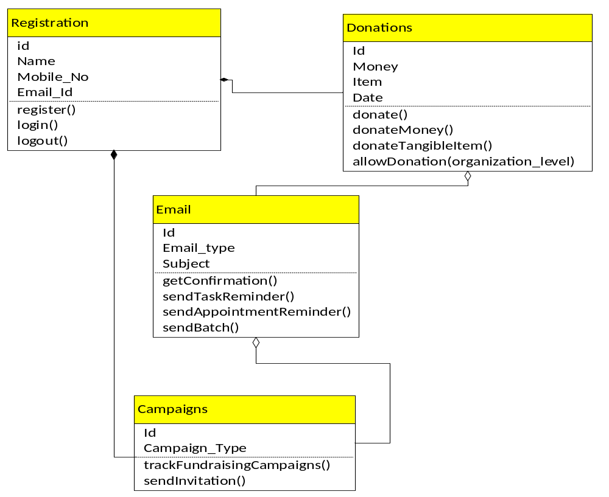

- Database Design:

- Interface Design

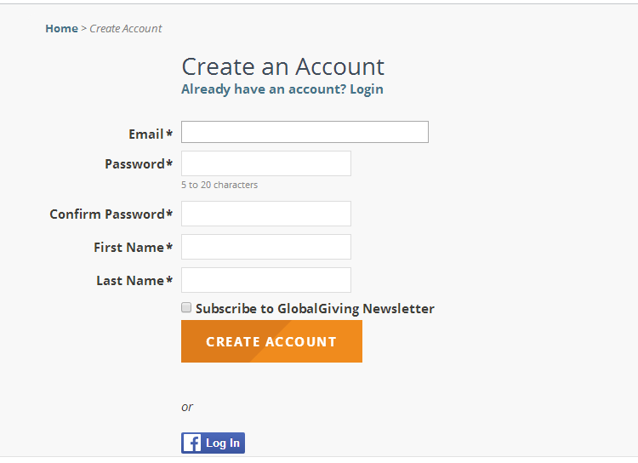
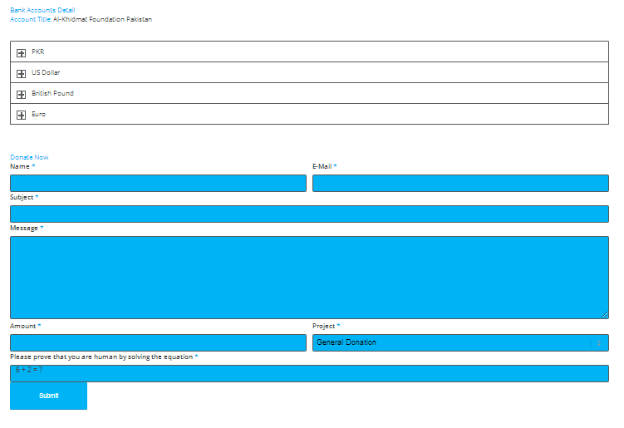

- Test Cases:

 | Registration
Actions | Open a registration form.
Pre-Conditions | User is logged into System.
Expected Result: | User is registered. after registration users are allowed to login.
Tested by | S2002687F7
Result | Pass

 | Login
Actions | - User can login to its account  - System will check the email and password
Pre-Conditions | The user information was previously saved to the system and the system will check.
Expected Result | After matching user info system allow the user to proceed.
Tested by | S2002687F7
Result | Pass

 | Logout
Action | User will logout from its account.
Pre-Conditions | Before logout user can do any process which is allowed to its role.
Expected Result | After logout user can login again
Tested by | S2002687F7
Result | Pass

 | Add Hall
Action | User(hall manager) will add new hall with required details
Pre-Conditions | Before logout user can add another hall.
Expected Result | New hall.
Tested by | S2002687F7
Result | Pass.

 | search Hall
Action | User(customer) can search a hall by its name, price, location etc.
Pre-Conditions | Before logout user can search another hall.
Expected Result | Halls list.
Tested by | S2002687F7
Result | Pass.

 | Place booking
Action | User(customer) can book a hall with required details
Pre-Conditions | Before logout user can book another hall.
Expected Result | New booking.
Tested by | S2002687F7
Result | Pass.

 | Give feedback
Action | User(customer) can give feedback to a hall depending on his/her experience
Pre-Conditions | Before logout user can give feedback to another hall.
Expected Result | Hall feedback added.
Tested by | S2002687F7
Result | Pass.

 | Approve Hall
Action | User(Admin) can approve a hall
Pre-Conditions | Before logout user can approve another hall.
Expected Result | Hall approve.
Tested by | S2002687F7
Result | Pass.

 | Disapprove Hall
Action | User(Admin) can disapprove a hall
Pre-Conditions | Before logout user can disapprove another hall.
Expected Result | Hall disapprove.
Tested by | S2002687F7
Result | Pass.

 | Add Hall Food Menu
Action | User(hall manager) can add hall food menu
Pre-Conditions | Before logout user can add another hall food menu.
Expected Result | Hall food menu.
Tested by | S2002687F7
Result | Pass.

 | Add Hall
Action | User(hall manager) will add new hall with required details
Pre-Conditions | Before logout user can add another hall.
Expected Result | New hall.
Tested by | S2002687F7
Result | Pass.

*****************************************

